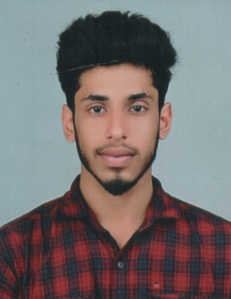

CURRICULAM VITAE

ANANTHU JOSE

Mob: +65 88461417, +65 89020565

ananthujosethekkekuttu@gmail.com

Home town Address: -
THEKKEKUTTU (H), ERATTAYAR P.O
IDUKKI (DIST), PIN. 685514
KERALA, INDIA

CAREER OBJECTIVE
To work in a professional environment where my qualifications and experience provides me an opportunity for advancement and challenge to handle responsible where I can show my caliber, work skills and strength for betterment of the organizational growth.

PERSONAL PROFILE
Name : Ananthu Jose
Date of Birth : 26th November 1996
Gender : Male
Nationality : Indian
Languages Known : English, Malayalam and Tamil
Nationality : Indian
Passport No : T 0415197

EDUCATIONAL QUALIFICATION
Diploma in Electrical and Electronical Engineering (E.E.E) | Tamilnadu, India | 2015-18
PLUS TWO | Kerala, India | 2013-15

TECHNICAL QUALIFICATION
- M.S Office & Data Entry

- Internet browsing & E-mail

WORKING EXPERIENCE

SEMB CORP MARINE ADMIRALY YARD, SINGAPORE (From 29th May 2019)

A qualified Electrical Technician and more than 4 years of industrial experience in troubleshooting, diagnosing electrical issues, and implementing effective solutions to optimize the performance of onboard electrical components.
JOB PROFILE AND EXPERIENCE
- Executed marine electrical repairs and maintenance, ensuring the seamless functioning of electrical systems and components on various LNG & Navy vessels
- Trained in rotating apparatus repair of AC and DC electric motors, pumps & blowers
- Experienced with electronic troubleshooting equipment including multi-meters, mega ohm meters, hi pot testers & surge tester to make necessary repairs
- Demonstrated expertise in adhering to safety protocols and industry regulations while performing electrical work in a maritime environment.

- Duties and Responsibilities

- Fault rectification duties.
- Repairs, modifications, and preventative maintenance procedures to meet operational requirements of workshop.
- Serviced, inspected and breakdown repairs.
- Equipment isolations & safe testing.
- Overhaul A.C and D.C motors.
- Submission of daily report and assorting job to juniors.
DECLARATION

I hereby declare that the above information’s given are true to my knowledge.

DATE:

PLACE:
ANANTHU JOSE

